Sprint 5:

Task 1: DGDB Schema:

SQL DDL scripts for creating your DGDB tables
The file named DGDB_DDL.sql in folder Codes

Documentation of your schema design choices
Four tables have been created to track the validation and apply the rules and handle the errors within the ETL, such as follows:
- ETL_Runs: Tracks when ETL jobs run, their duration, and whether they succeed or fail. Created to monitor pipeline reliability and performance.
- Validation_Rules: Stores all data quality rules. Created to make validations flexible and centrally managed.
- Validation_Results: Logs the outcome of every validation. Created to provide historical data quality reporting.
- Data_Lineage: Documents where data came from and how it was transformed. Created to support full data transparency and merger documentation.

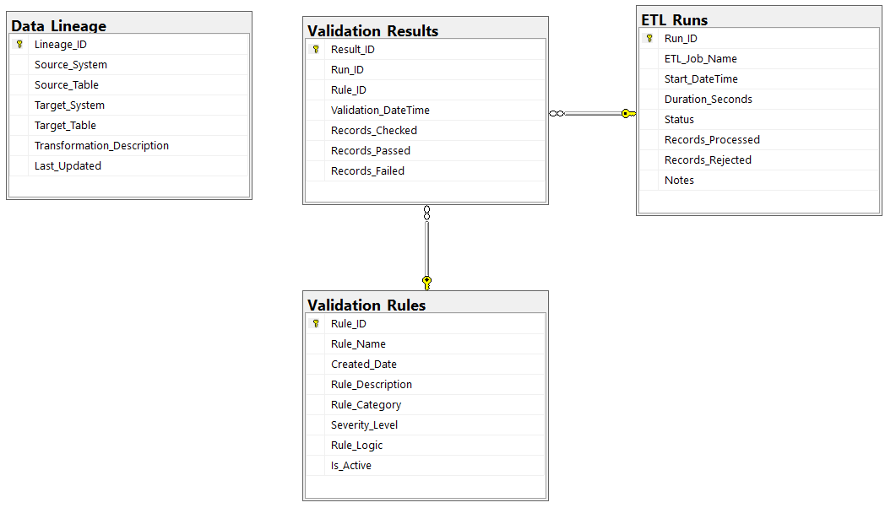

Task 2: Validation Rules Documentation:

Plain English document explaining your validation rules

1. Customer must have a valid AddressKey
Category: Referential Integrity
Severity: Critical
SELECT COUNT(*) FROM WarehouseDB.dbo.DimCustomer cLEFT JOIN WarehouseDB.dbo.DimAddress a
ON c.AddressKey = a.AddressKeyWHERE a.AddressKey IS NULL;

2. Product must have a valid SupplierKey
Category: Referential Integrity
Severity: Critical
SELECT COUNT(*)FROM WarehouseDB.dbo.DimProduct pLEFT JOIN WarehouseDB.dbo.DimSupplier s
ON p.SupplierKey = s.SupplierKeyWHERE s.SupplierKey IS NULL;

3. Product must have a valid CategoryKey
Category: Referential Integrity
Severity: Critical
SELECT COUNT(*)FROM WarehouseDB.dbo.DimProduct pLEFT JOIN WarehouseDB.dbo.DimCategory c
ON p.CategoryKey = c.CategoryKeyWHERE c.CategoryKey IS NULL;

4. FactSales must reference valid Product, Customer, Employee, and Date
Category: Referential Integrity
Severity: Critical
SELECT COUNT(*)FROM WarehouseDB.dbo.FactSales fsLEFT JOIN WarehouseDB.dbo.DimProduct p ON fs.ProductKey = p.ProductKeyLEFT JOIN WarehouseDB.dbo.DimCustomer c ON fs.CustomerKey = c.CustomerKeyLEFT JOIN WarehouseDB.dbo.DimEmployee e ON fs.EmployeeKey = e.EmployeeKeyLEFT JOIN WarehouseDB.dbo.DimDate d ON fs.OrderDateKey = d.DateKeyWHERE p.ProductKey IS NULLOR c.CustomerKey IS NULLOR e.EmployeeKey IS NULLOR d.DateKey IS NULL;

5. FactSales cannot contain negative values
Category: Business Logic
Severity: Critical
SELECT COUNT(*)FROM WarehouseDB.dbo.FactSalesWHERE Quantity < 0 OR UnitPrice < 0 OR Discount < 0;

6. FactSalary must have valid date ranges
Category: Business Logic
Severity: Critical
SELECT COUNT(*)FROM WarehouseDB.dbo.FactSalaryWHERE FromDateKey > ToDateKey;

7. Employee must have a valid AddressKey
Category: Referential Integrity
Severity: Critical
SELECT COUNT(*)FROM WarehouseDB.dbo.DimEmployee eLEFT JOIN WarehouseDB.dbo.DimAddress a
ON e.AddressKey = a.AddressKeyWHERE a.AddressKey IS NULL;

8. Customer email must be in a valid format
Category: Format Validation
Severity: Warning
SELECT COUNT(*)FROM WarehouseDB.dbo.DimCustomerWHERE Email NOT LIKE '%@%.%';

9. No duplicate EmployeeKey values allowed
Category: Uniqueness
Severity: Critical
SELECT COUNT(*)FROM (
SELECT EmployeeKey
FROM WarehouseDB.dbo.DimEmployee
GROUP BY EmployeeKey
HAVING COUNT(*) > 1) x;

10. SourceSystem for DimCustomer must be valid
Category: Merger Logic
Severity: Critical
SELECT COUNT(*)FROM WarehouseDB.dbo.DimCustomerWHERE SourceSystem NOT IN ('Sakila', 'Northwind', 'Employees');

11. Product SourceSystem must match Supplier SourceSystem
Category: Merger Logic
Severity: Warning
SELECT COUNT(*)FROM WarehouseDB.dbo.DimProduct pJOIN WarehouseDB.dbo.DimSupplier s
ON p.SupplierKey = s.SupplierKeyWHERE p.SourceSystem <> s.SourceSystem;

12. FactRental must have valid date relationships
Category: Business Logic
Severity: Warning
SELECT COUNT(*)FROM WarehouseDB.dbo.FactRentalWHERE ReturnDateKey IS NOT NULLAND RentalDateKey > ReturnDateKey;

Explanation of how you handle validation failures
Validation failures are recorded during each ETL run in the Data Governance table.
If a rule marked as Critical fails, the ETL is flagged as Failed to prevent using bad data.
Warnings are logged but do not stop the ETL, allowing the process to finish normally.
The below screenshots show the demonstration of the validation within running the ETL:

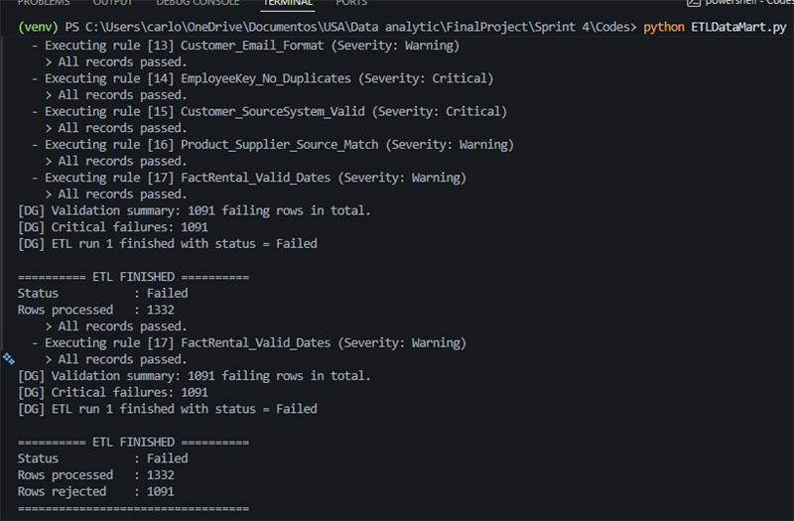
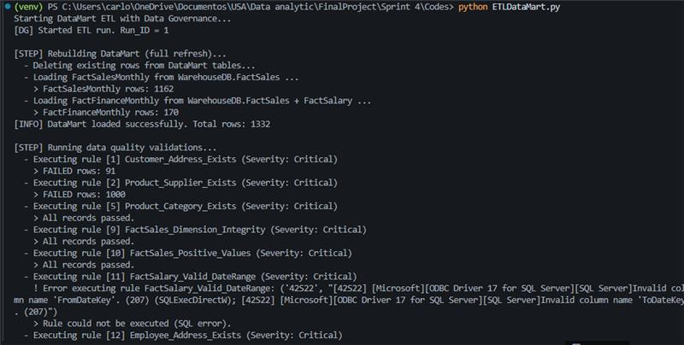

Task 3: Updated ETL Code:

ETL Code:
The file named Sprint5_Task3_ETL.py in folder Codes

Validation Rules tables:
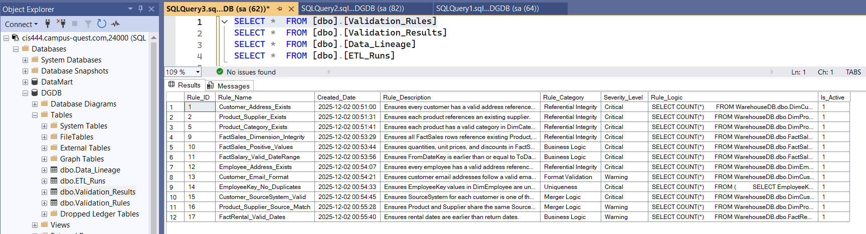

Validation Results Table:
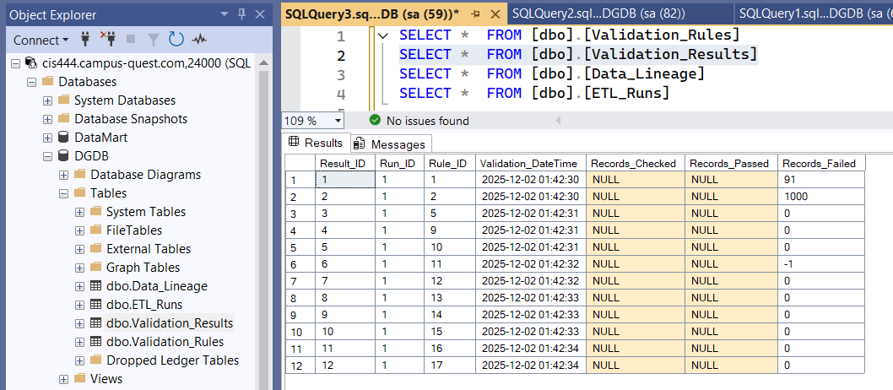

Data Lineage Table:
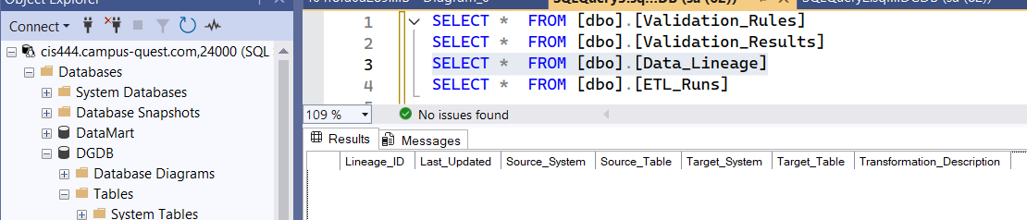

ETL Runs Table:
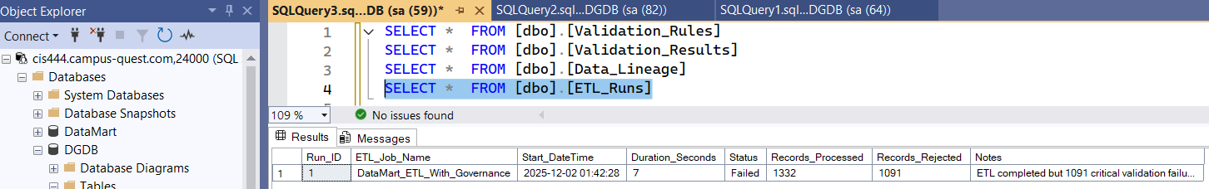

Task 4: At Least One Dashboard:
The Power BI is in the file sprint 5, the name is Sprint5.pbix

PAGE 1 - Data Warehouse Dashboard
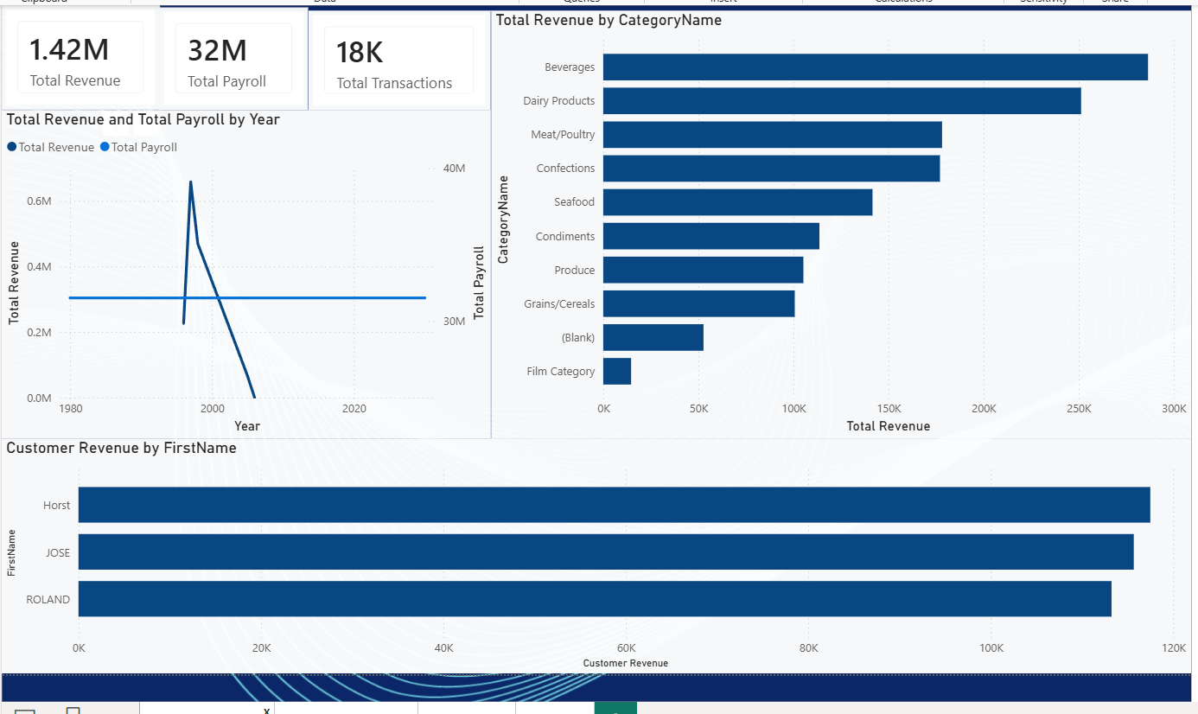

Purpose
This dashboard provides executives with a high-level overview of the company’s consolidated performance after merging multiple operational systems. It focuses on organization-wide revenue, payroll, customer activity, and category-level performance.

Audience
Executive leadership, finance directors, and strategic planning teams.

Business Questions Answered
- How much total revenue and payroll has the merged company generated?
- How do revenue and payroll trends evolve over time?
- Which product categories drive the most revenue?
- Who are the top customers based on sales performance?

Data Sources
SQL Server Data Warehouse (Star Schema):
- FactSales, FactSalary
- DimCustomer, DimProduct, DimCategory
- DimEmployee, DimDate

Key Visuals Included
- KPI Cards
  - Total Revenue
  - Total Payroll
  - Total Transactions
These KPIs provide executives with instant financial benchmarks.
- Revenue & Payroll Trend (Line Chart)
  - Plots Total Revenue and Total Payroll across years.
  - Helps identify growth, declines, and structural changes.
- Total Revenue by Category (Bar Chart)
  - Highlights strongest and weakest business areas.
  - Useful for strategic product and marketing decisions.
- Top Customers by Revenue (Horizontal Bar Chart)
  - Shows which customers generate the highest revenue.
  - Useful for customer relationship strategy and retention analysis.

Interactivity
- Cross-filtering between visuals
- Drill-down through date hierarchy
- Optional slicers (Year, Category, Customer)

Notes
This dashboard is designed for rapid decision-making and provides a consolidated financial overview without requiring detailed navigation.

PAGE 2 - Data Warehouse Dashboard
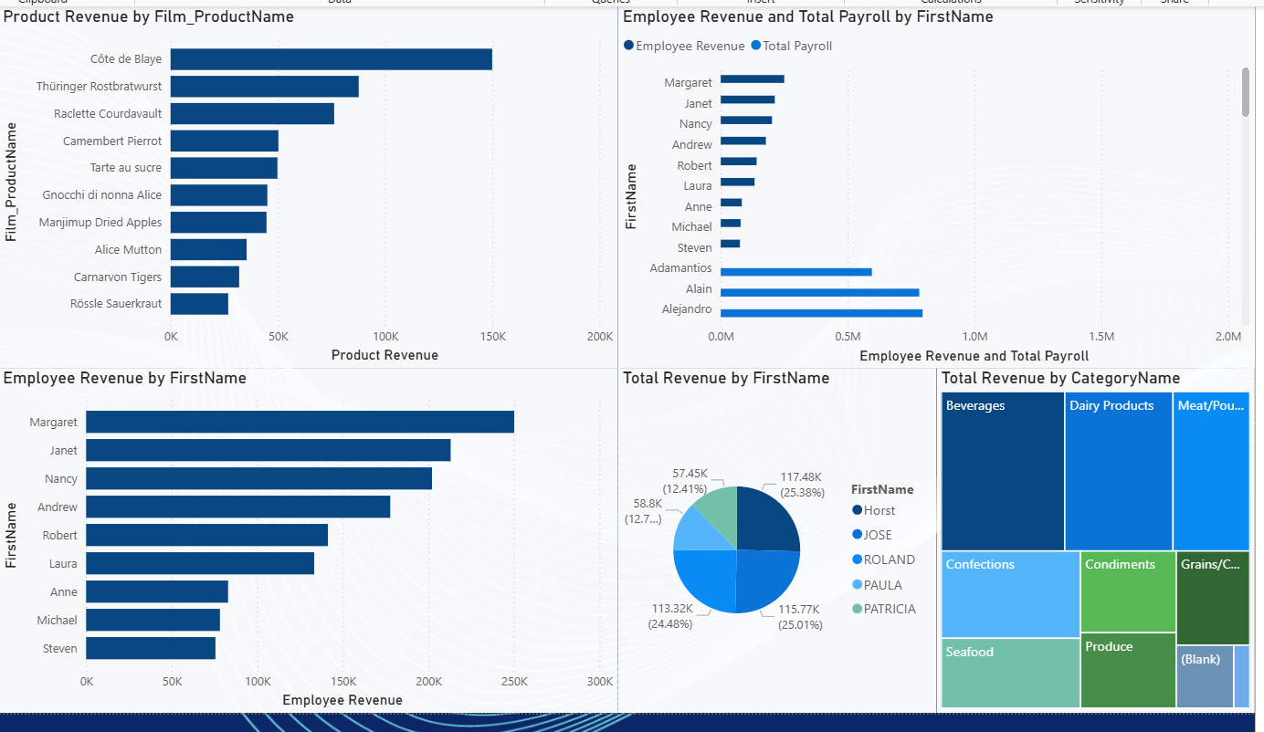

Purpose
This second dashboard page expands into more detailed departmental insights, combining product-level, employee-level, and time-based financial information.

Audience
Department managers, product teams, and financial analysts.

Business Questions Answered
- Which individual products generate the most revenue?
- How does employee revenue compare to payroll costs?
- What are the strongest and weakest years by revenue?
- What is the distribution of revenue across top contributors?

Data Sources
Data Warehouse enriched tables:
- FactSales, DimProduct
- DimEmployee, DimCustomer
- DimDate

Key Visualizations Included
- Product Revenue by Film/Product
Shows the top 10 products by revenue, highlighting which SKUs drive organizational sales.
- Employee Revenue vs. Payroll (Clustered Bar)
  - Compares employee-generated revenue against payroll cost.
  - Identifies high-impact contributors and cost inefficiencies.
- Employee Revenue by FirstName (Bar Chart)
  - Ranks employees by total sales generated.
  - Useful for HR performance evaluation.
- Total Revenue by FirstName (Pie Chart)
  - Visualizes percentage contribution from top customers.
- Treemap - Total Revenue by CategoryName
  - High-level comparison of category performance.
  - Intuitive visual for identifying large vs. small segments.

Interactivity
- Visuals dynamically cross-filter one another
- Users can isolate departments, categories, or individuals
- Pie chart supports drill-down and segment highlighting

Notes
This page allows deeper exploration into operational performance, enabling departments to evaluate productivity, contributions, and profitability drivers.

PAGE 3: Department Dashboard - DataMart
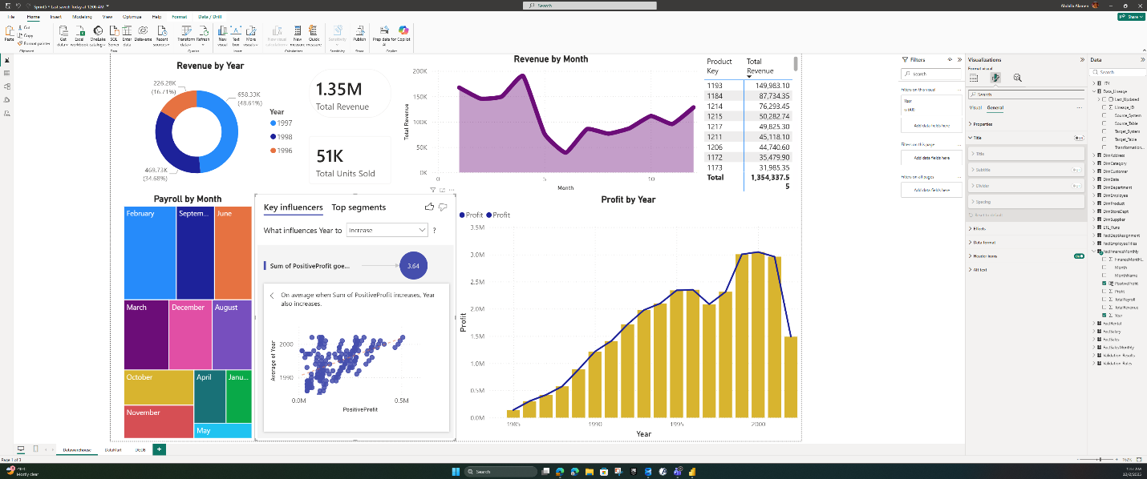

Purpose
Provide deeper analysis focused on financial performance of the merged companies, including trends, profit insights, payroll distribution, and time-based revenue patterns.

Intended Audience
- Finance department
- Controllers / FP&A teams
- Department managers

Business Questions Answered
- How does revenue change by year and by month?
- What is total profit and how has it evolved?
- Which months have the highest or lowest payroll expenses?
- What factors influence yearly variation in performance?
- Which products generate the most profit?

Data Sources
DataMart tables, created in Sprint 4 ETL:
- FactSalesMonthly
- FactFinanceMonthly
- DimDate
- DimProduct

Visualizations Included
- Donut Chart: Revenue by Year
- Line Chart: Revenue by Month
- Treemap: Payroll by Month
- Bar Chart: Profit by Year
- Key Influencers Visual: Identifies what affects yearly revenue increases or decreases
- KPI Cards:
  - Total Revenue
  - Total Units Sold

Interactivity
- Drill down on date hierarchy
- Slicers for Year / Month / Product
- Automatic cross-filtering between charts
- Key Influencers provides advanced interaction and segmentation

PAGE 4 - DGDB Dashboard
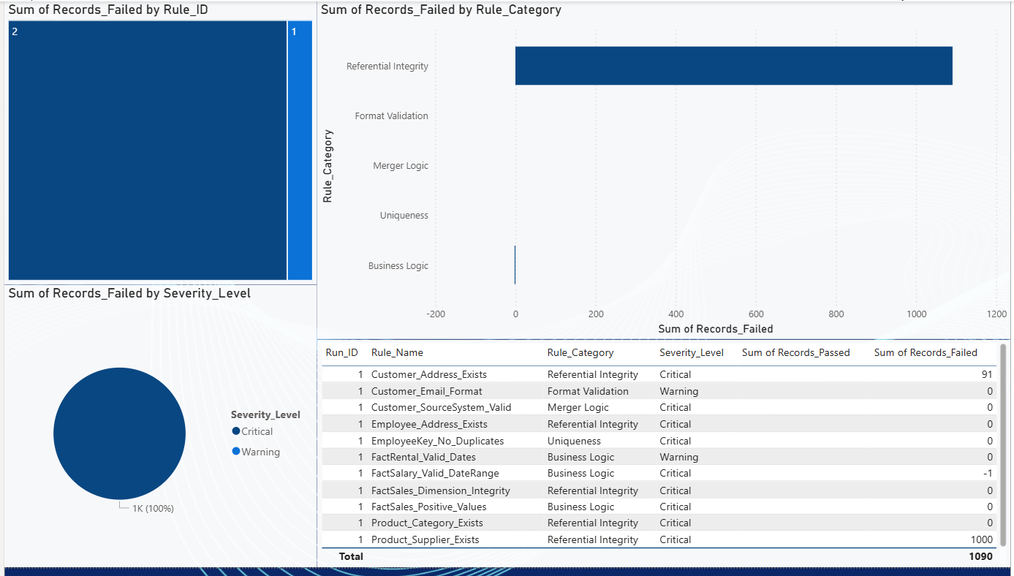

Purpose
This dashboard monitors ETL data quality, validation results, and rule-level integrity checks across the data pipeline. It ensures executives and engineering teams are aware of data reliability risks.

Audience
Data engineering teams, QA testers, governance officers.

Business Questions Answered
- Which validation rules failed during the latest ETL process?
- What categories of quality issues are most common (e.g., referential integrity, merger logic, format validation)?
- How many records passed vs. failed per rule?
- What is the severity distribution of data quality issues?

Data Sources (DGDB)
- Validation_Rules – Rule definitions, severity, categories
- Validation_Results – Pass/failed counts per ETL run
- ETL_Runs – Metadata including timestamps and status
- Data_Lineage – Source-system origin tracking

Visualizations Included
- Treemap – Failed Records by Rule_ID
  - Shows which rules failed most heavily.
- Bar Chart – Failed Records by Rule Category
  - Highlights dominant data quality issues
(e.g., Referential Integrity > 1,000 failures).
- Pie Chart – Failures by Severity Level
  - Critical vs. Warning distribution.
- Detailed Rule Table
  - Rule name
  - Category
  - Severity
  - Passed and Failed counts

Interactivity
- Selecting a rule filters the entire report
- Cross-highlighting between categories and severity
- Full drill-through into detailed rule records (optional)

Notes
This dashboard is essential for maintaining trustworthy analytics. It provides transparency into data health and informs engineers when immediate corrective action is required.

Task 5: Sprint Documentation:
9/9/2025 | Project Day 1:  Trello board created, checklist for sprint 1, member invites sent. Work space installed, first look at databases.  Group decided to start with Employees as the initial database. | 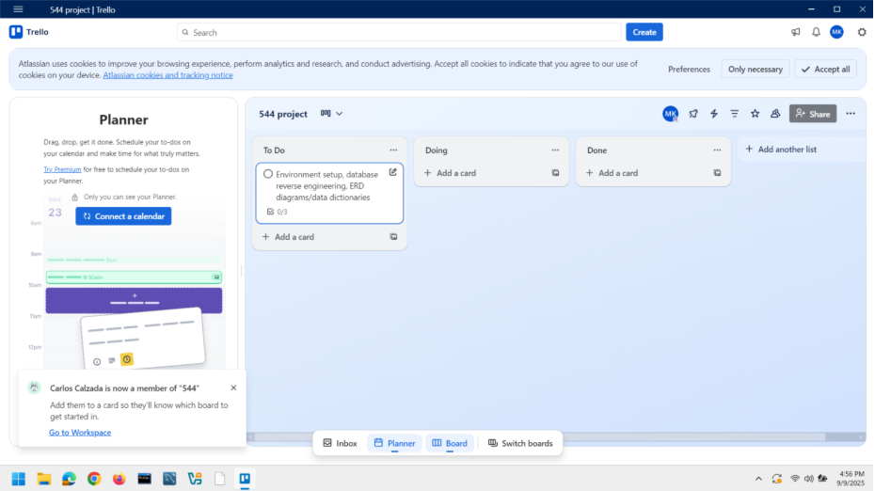
9/11/2025 | Choose Lucidchart to multiple member contribution.  Stand up meeting: we are working on sakila as primary;  We are doing ERDs together, | use sakila;  select count(title) from dbo.film;  EXEC sp_spaceused 'dbo.film';  SQL server’s stored procedure to show table’s disk space.  Dbo.film 1000 records, size 616 kb(344 kb);  Dbo.film_actor 5462 records, 672 kb(144 kb);  Dbo.film_category 1000 records, 288 kb(32 kb);  Dbo.film_text 0/0/0  Key people are customers, actors, staff members.  Actor – plays a role in a movie  Staff – employee in a rental store  Customer – rents a movie at a store.  Stand-up meeting 9/11/2025:  Mary: I’ working on film. Tables: film, film.actor, film.category, film.text and understanding the data types; I need help with my craw feet.  Rena: working on address, city, country, customer; I don’t need help  Carlos: I’m working on Staff, Rental, Payment, Inventory; I don’t need help;  Abdalla: I’m working on Store, Actor, Language, Category…, I don’t need help
9/18 | ERD is done. | 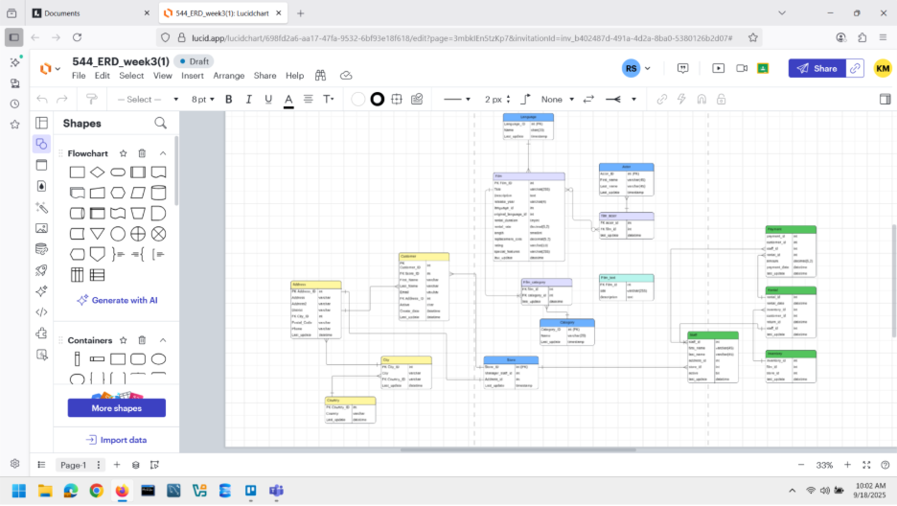
9/23/25 | Written team "contract"/plan: team member roles, project mngmt platform, plan for having standup meetings | Project management platform: Trello.  Team member roles: conjoined quadruplets  Standup meetings plan: during class times.  Group contract finalized.
9/25/25 |  | Mary: I am Importing data into dbmongo using compass:  Select * from dbo.actor; …..
9/30/25 |  | Mary: I’m struggling to import sakila db into Mongo. Seems to be a software issue.  Abdalla: I have a code to import the entire sakila DB using python.  Carlos: I can debug the python code to import the sakila DB  Rena: we need to make a folder pyodbc for a library.  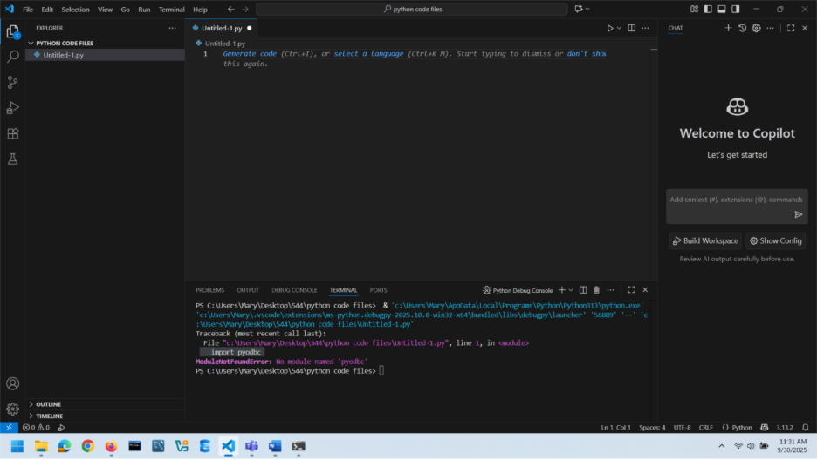
10/2/25 | Sakila DB is successfully loaded into mongo DB using compass.  mary: ERD for star schema, ready before Tuesday class  rena:  abdalla:  carlos: | 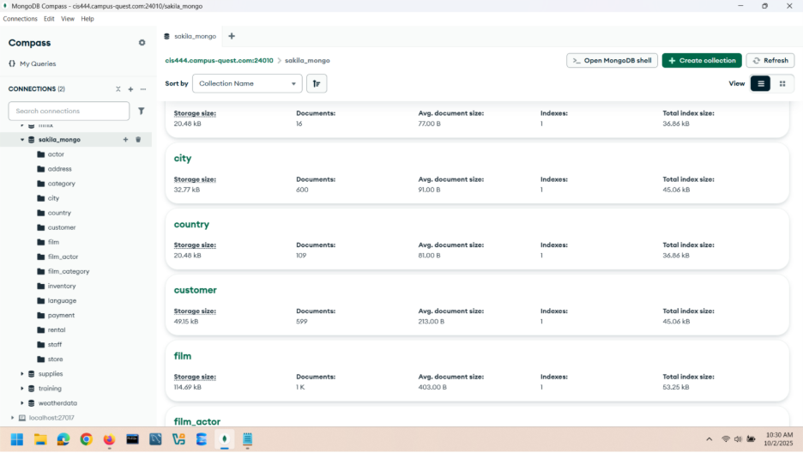
10/6/25 | Sprint 2: deliverables: Star schemas for business use case | Mary: Star schema 1: rentals  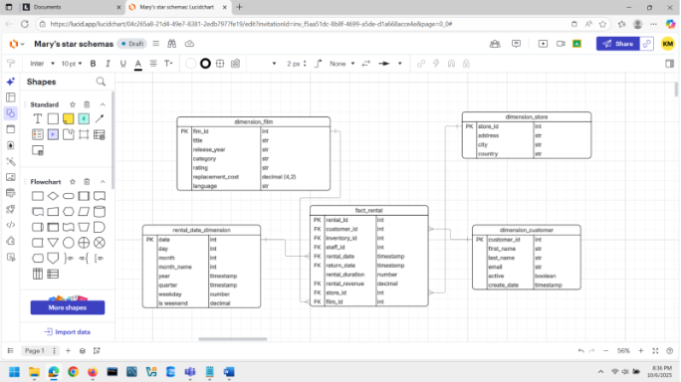  Star schema 2: geographic imprint  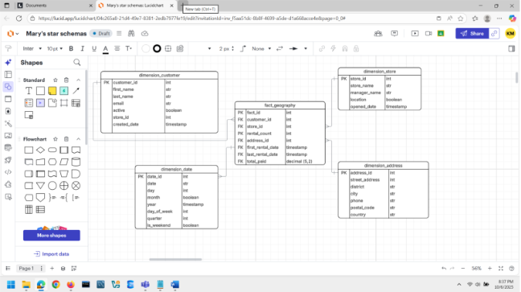  Star schema 3: Top rented movies durin x week of y month of z year  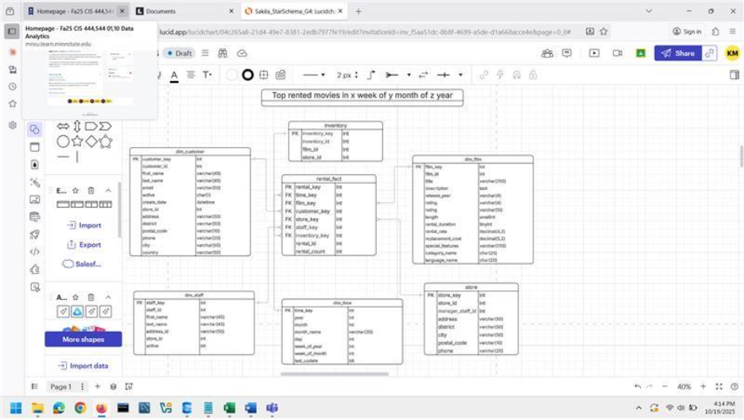  Link to lucidchart: https://lucid.app/lucidchart/04c265a8-21d4-49e7-8381-2edb7977fe19/edit?viewport_loc=-14649%2C-25246%2C2287%2C1094%2C0_0&invitationId=inv_f5aa51dc-8b8f-4699-a5de-d1a668acce4e
10/28/25 | Sprint 3: Data Warehousing I  Deliverables 3.1. Design and implement at least three star schemas in Microsoft SQL Server | sakila DB in in Mongo DB. Now we have to load the Employee and Northwind into Mongo.  Carlos and Abdalla: we will work on it.  Mary: Abdalla: make ERDs for these 3 business queries.  Standup meeting 10/28/25:  Mary: Star schemas implemented in SQL server. I have the idea of the merger, I just have to write it all down.  Carlos- “Mary’s star schemas did not make any sense so I have re-done them”  The star schemas in sql servers are still the same.  (Carlos meant the ERDs apparently.)  Neither Employee nor Northwind databases are in mongo db.  Abdalla divided the tasks. I’ve done the star schemas, but that “doesn’t count now”  According to Abdalla, now Abdalla is making the star schemas in SQL server.  Mary: I will write down the details of the merger and get it finished.
11/4/25 |  | Standup meeting 11/4/25:  Abdalla. Sprint 3 tasks: not complete  Carlos: sprint 3 tasks: not complete  Rena: sprint 3 tasks: finishing up  Mary: sprint 3 tasks - merger complete.
11/6/ 2025 | Trello task manager  (standup) Meeting notes: tasks divided: Carlos and Abdalla are writing the ETL,  Rena is writing the stored procedures, ‘Mary 0 is writing the validation plan for the merger data warehouse. | 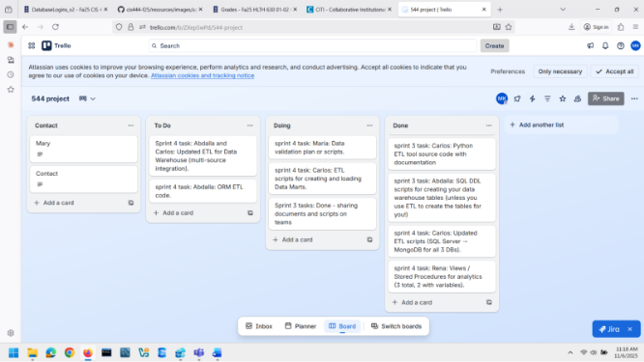
11/11/25 | Standup meeting sprint 4 | Carlos: I am debugging the code errors ETL for the warehouse, Abdalla: I am helping Carlos Debug the code  Rena: “I wrote stored procedures, but the the code errors need to be debugged first.  Mary: I wrote the validation plan and the SQL code. Let me know if anything needs to be added.
11/13/25 | Standup meeting sprint 4 | Abdalla: I am working on debugging the ETL and adjusting the ERDs.  Carlos: I was working on the same thing all night  Mary: I am cleaning up the screenshots and the stand-up meeting notes  Rena: I was working on my queries to match the ERDs.
11/18/25 | Standup meeting sprint 4 | Abdalla: I have debugged all scripts that bring all the data from multiple sorces  Carlos: I have loaded all 3 DBs to Mongo  Rena: I’m writing scripts fro view/procedures for analytics  Mary: I’m keeping standup meeting notes. I see that the data-mart has different data from those in data warehouse, I’ll make sure we have a validation plan to match that.  Next, we need 3 steps for datamart creation, validation (as written in Mary’s plan), ORM
11/20/25 | Standup meeting sprint 4 | Rena: I did sprint 4 Scripts for views/stored procedures using Sprint3New_ERD  Abdalla: I’m still looking at the ETL – Employees DB keeps getting interrupted after 5 hours. Sakila and Northwind transfer is complete.  Carlos: I am working on ETL tool with Abdalla. Once Employee DB is transferred, I will work on data mart and ORM.  Mary: I have completed the Data Validation Plan for the working Sakila Star schemas from Abdalla. I will make a new Data Validation Plan, again, after we have all the 3 DBs transferred in to SQL server.
12/2/25 | Standup meeting sprint 5 | Abdalla & Carlos: we have completed the project.

